Aviel Resnick

Week 27 Problem Set

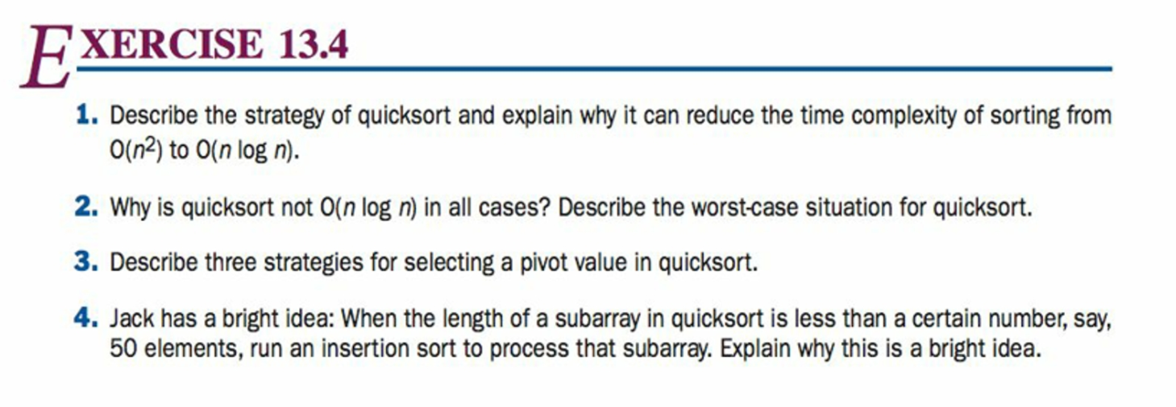

1. Quick sort works by randomly selecting a pivot point and then shifting all the elements less than the pivot value to the left and greater than the value to the right. This occurs at a linear rate. Then quick sort is used (recursively) on the left and right halves. Shifting is logarithmic if the pivot index is in the center, which reduces the complexity to O(*n* log *n*)
2. Because in the worst-case, which occurs when the pivot index is at either end, the runtime in O(*n2*).
3. The first method is to simply use a random value within the array. Another, and generally considered the best, is the use the median value. The final option is to create a sub array, and then choose its median..
4. A subarray by definition is either a) sorted, or b) almost sorted. At that point, insertion sort would run almost linearly, hence the bright idea. This also works well with small arrays, though at that size runtime doesn’t really matter.